**Software Design & Architecture**

**Assignment No. 4**



**Session: 2021**

**Submitted by:**

**Wali Muhammad 2021-SE-39**

**Submitted to:**

**Sir Zeeshan Ramzan**

Department of Computer Science, New Campus

**University of Engineering and Technology Lahore, Pakistan**

**UML Activity Diagram**

**Diagram #1**

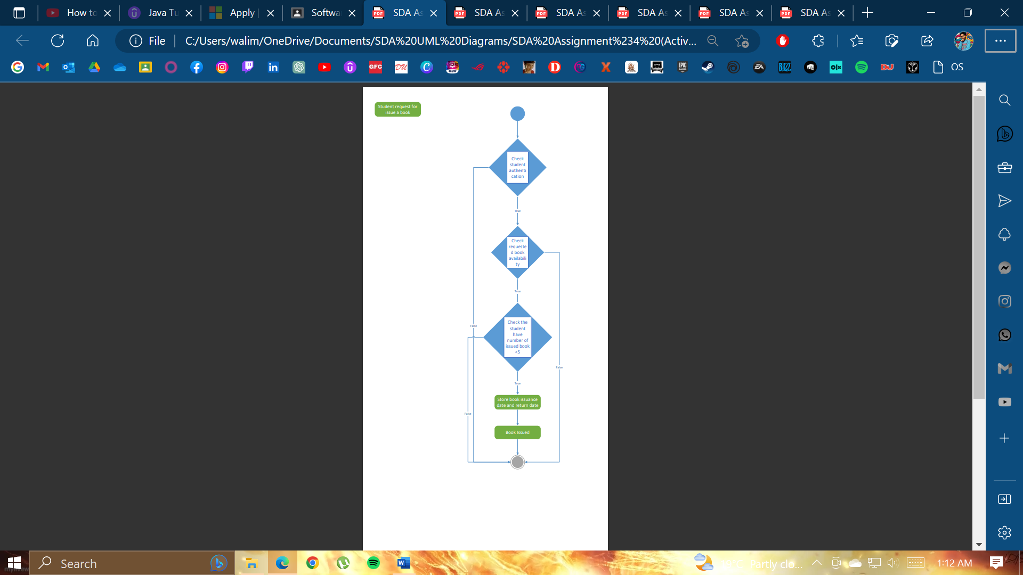

**Diagram #2**

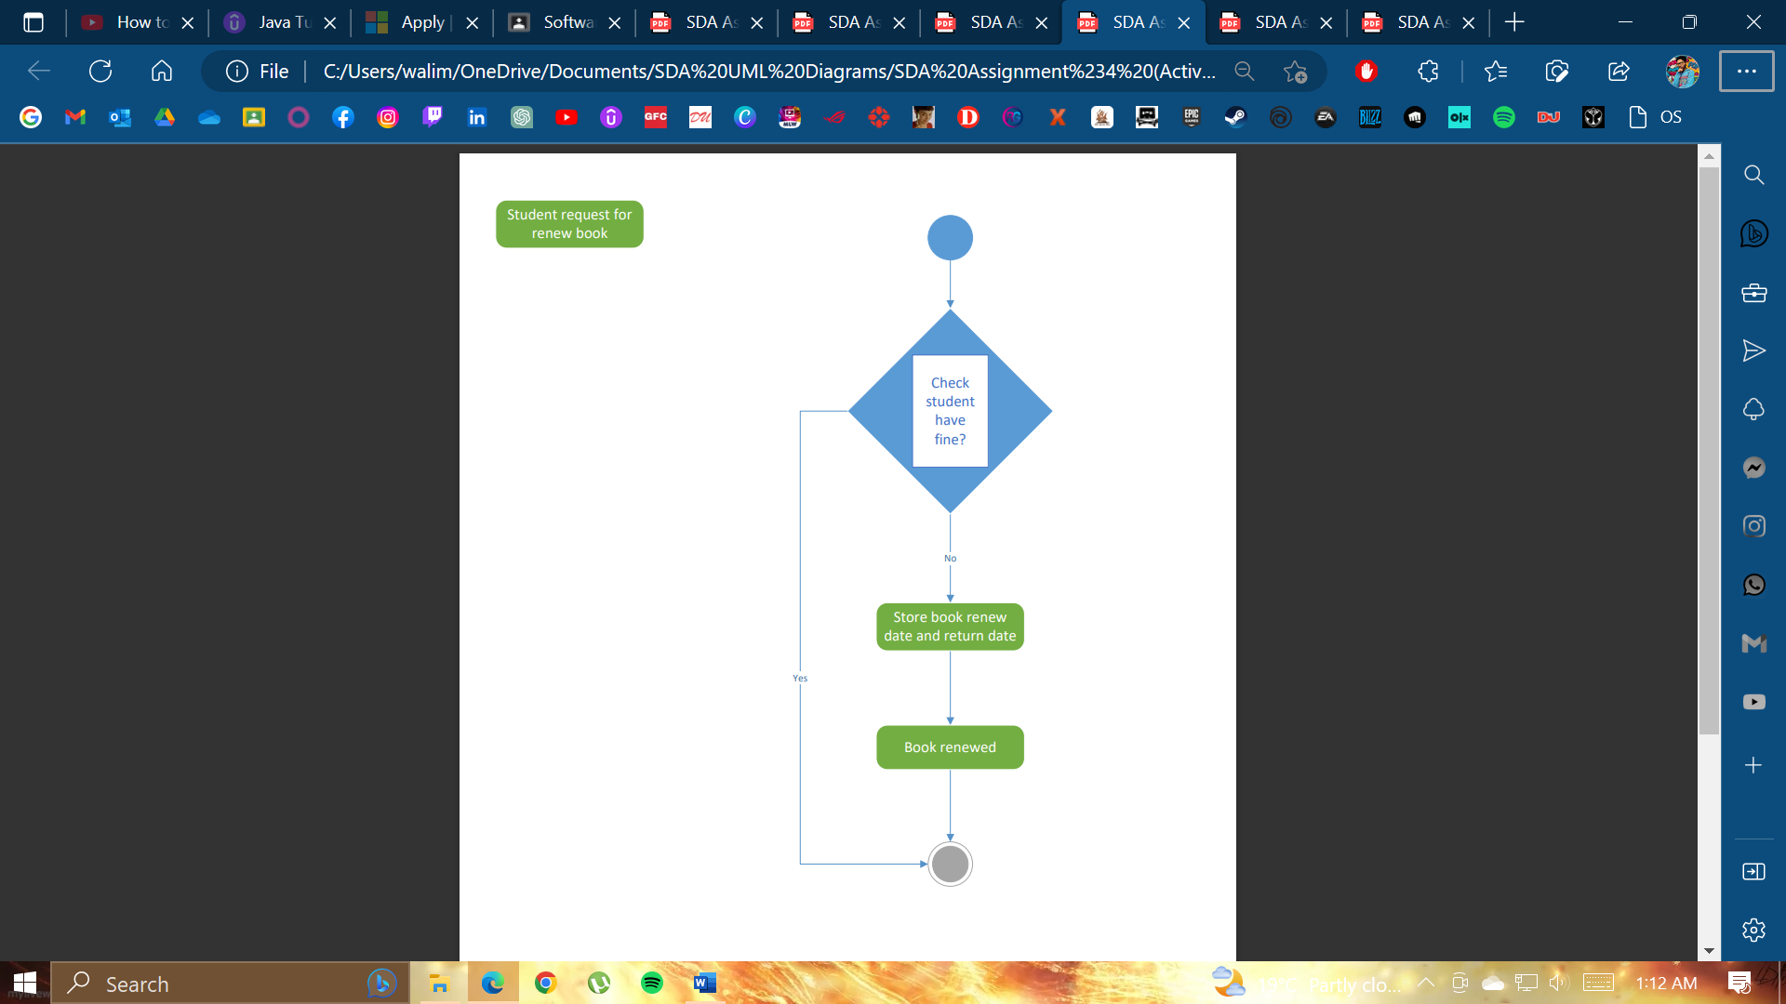

**Diagram #3**

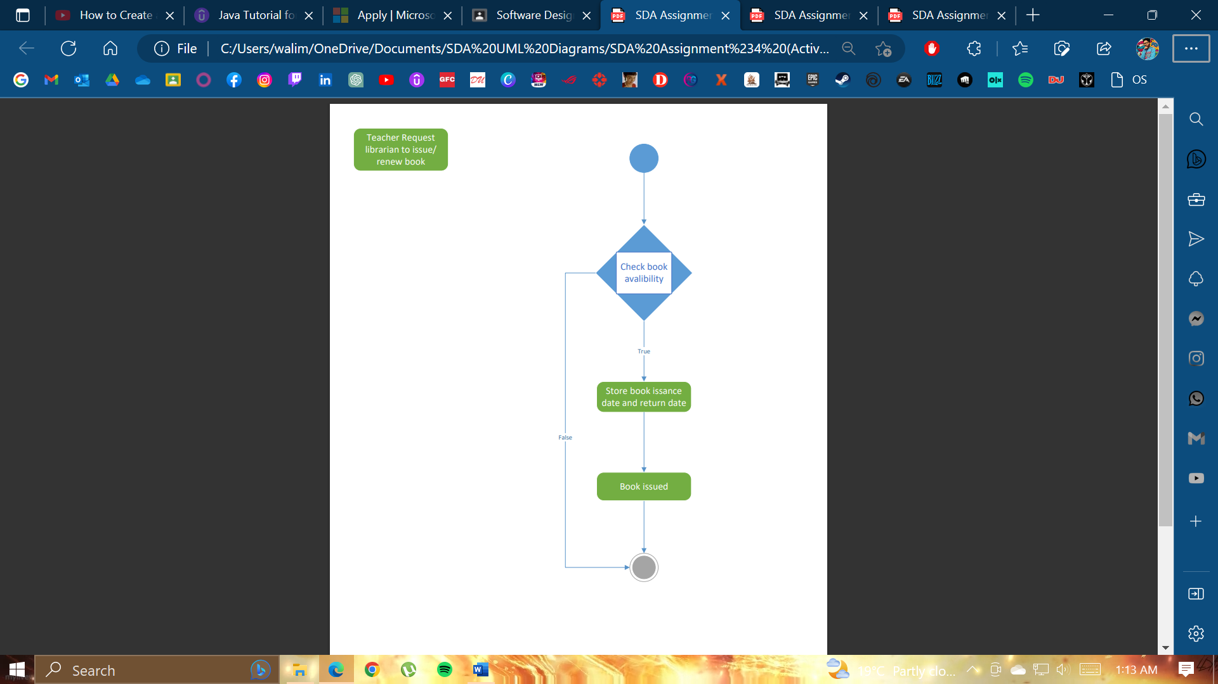

**Diagram #4**

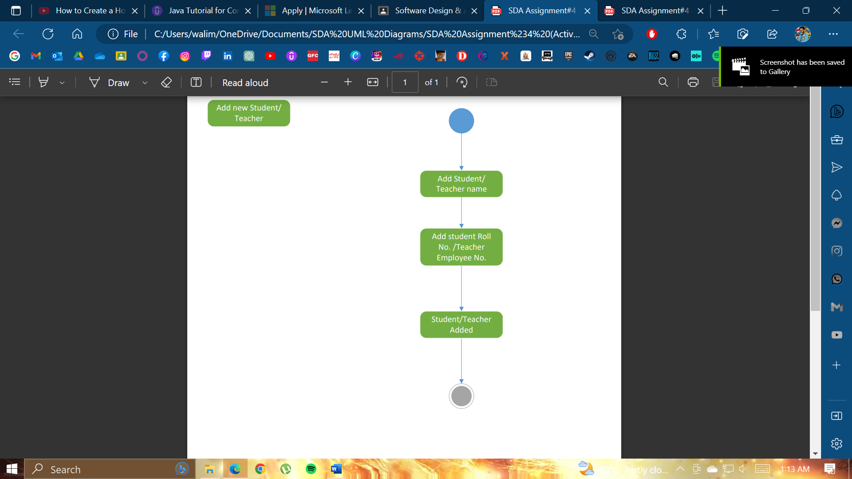

**UML State Machine Diagram #1-4**

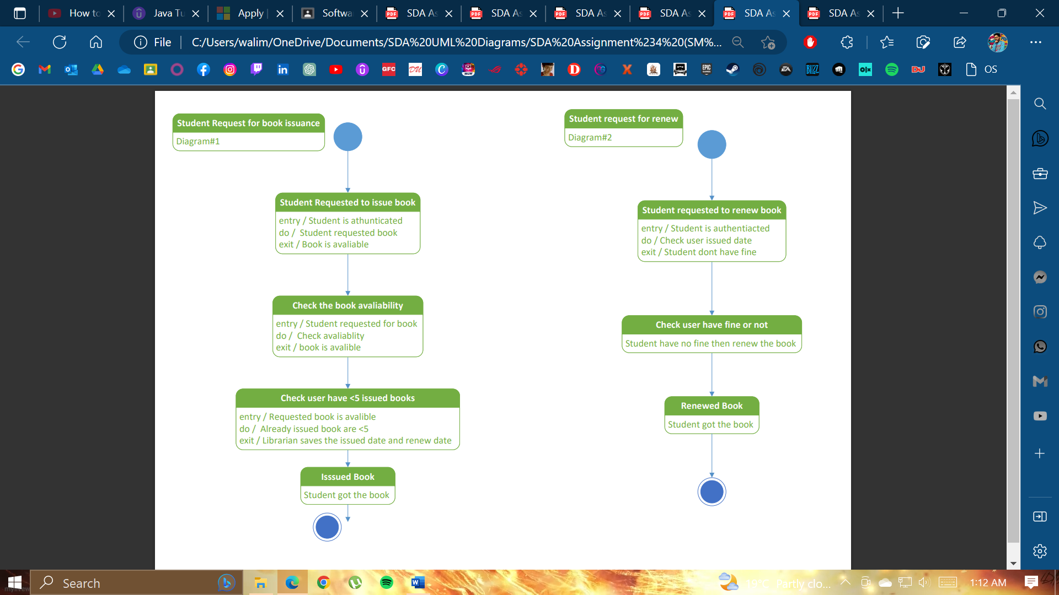

**UML State Machine Diagram #3-4**

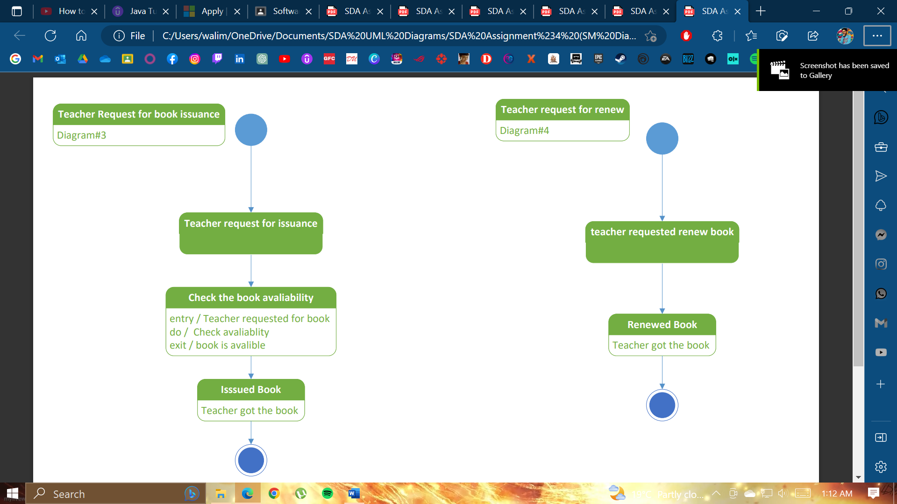

**THE END**